**Divorce Prediction: Man vs. Machine**

**Case Study Narrative Part 1**

**Objective:**

If you have read the book Blink by Malcolm Gladwell, then you might be familiar with Dr. John Gottman who is renowned in the field of psychology for being able to predict, with a high percentage of accuracy, couples that will divorce. By simply meeting with a couple and observing their interaction Dr. Gottman can identify negative communication patterns that reveal feelings of criticism, contempt, defensiveness, and stonewalling. So, is there a way that we can use data science to identify who will divorce with more accuracy than Dr. John Gottman? Dr. Gottman boasts an accuracy rate of over 94%. The goal of my case study is to learn if machine learning can be used to predict who will divorce, with higher accuracy than the human expert.

**Dataset:**

The dataset being used was retrieved from UCI Machine Learning Repository.

With Dr. Gottman’s research in mind a group of other researchers created a dataset using a list of 54 statements that were meant to measure the respondent’s feelings toward their spouse or ex-spouse and the relationship. The statements were evaluated during an interview of 170 respondents containing both married and divorced participants and measured on a Likert style scale. 0=Never, 1=Seldom, 2=Averagely, 3=Frequently, 4=Always. One thing to keep in mind is that the researchers and respondents were from Turkey, so there are some places where the translation does not make grammatical sense in English, but you will be able to understand the gist of the statements.

Attributes:

1. If one of us apologizes when our discussion deteriorates, the discussion ends.  
2. I know we can ignore our differences, even if things get hard sometimes.  
3. When we need it, we can take our discussions with my spouse from the beginning and correct it.  
4. When I discuss with my spouse, to contact him will eventually work.  
5. The time I spent with my wife is special for us.  
6. We don't have time at home as partners.  
7. We are like two strangers who share the same environment at home rather than family.  
8. I enjoy our holidays with my wife.  
9. I enjoy traveling with my wife.  
10. Most of our goals are common to my spouse.  
11. I think that one day in the future, when I look back, I see that my spouse and I have been in harmony with each other.  
12. My spouse and I have similar values in terms of personal freedom.  
13. My spouse and I have similar sense of entertainment.  
14. Most of our goals for people (children, friends, etc.) are the same.  
15. Our dreams with my spouse are similar and harmonious.  
16. We're compatible with my spouse about what love should be.  
17. We share the same views about being happy in our life with my spouse  
18. My spouse and I have similar ideas about how marriage should be  
19. My spouse and I have similar ideas about how roles should be in marriage  
20. My spouse and I have similar values in trust.  
21. I know exactly what my wife likes.  
22. I know how my spouse wants to be taken care of when she/he sick.  
23. I know my spouse's favorite food.  
24. I can tell you what kind of stress my spouse is facing in her/his life.  
25. I have knowledge of my spouse's inner world.  
26. I know my spouse's basic anxieties.  
27. I know what my spouse's current sources of stress are.  
28. I know my spouse's hopes and wishes.  
29. I know my spouse very well.  
30. I know my spouse's friends and their social relationships.  
31. I feel aggressive when I argue with my spouse.  
32. When discussing with my spouse, I usually use expressions such as ‘you always’ or ‘you never’ .  
33. I can use negative statements about my spouse's personality during our discussions.  
34. I can use offensive expressions during our discussions.  
35. I can insult my spouse during our discussions.  
36. I can be humiliating when we discussions.  
37. My discussion with my spouse is not calm.  
38. I hate my spouse's way of open a subject.  
39. Our discussions often occur suddenly.  
40. We're just starting a discussion before I know what's going on.  
41. When I talk to my spouse about something, my calm suddenly breaks.  
42. When I argue with my spouse, ı only go out and I don't say a word.  
43. I mostly stay silent to calm the environment a little bit.  
44. Sometimes I think it's good for me to leave home for a while.  
45. I'd rather stay silent than discuss with my spouse.  
46. Even if I'm right in the discussion, I stay silent to hurt my spouse.  
47. When I discuss with my spouse, I stay silent because I am afraid of not being able to control my anger.  
48. I feel right in our discussions.  
49. I have nothing to do with what I've been accused of.  
50. I'm not actually the one who's guilty about what I'm accused of.  
51. I'm not the one who's wrong about problems at home.  
52. I wouldn't hesitate to tell my spouse about her/his inadequacy.  
53. When I discuss, I remind my spouse of her/his inadequacy.  
54. I'm not afraid to tell my spouse about her/his incompetence.

**EDA Graphical Analysis:**

The first visualization I choose to do was to plot the mean scores for all attributes by Class.

We can see that the general trend is that married persons scored statements in the higher ranges, with the exception of statements 6 and 7. Upon reviewing those statements, they do appear as negative statements, were most of the rest of the statement are more positive. But it’s important to note that all statements are not created equal. 0 is not always equal to bad and 4 is not always equal to good. We also see that statements 43, 46, and 48 scored the highest among the divorced persons.

The next visualization I choose was a correlation heatmap.

As you can see, due to the sheer number of features this correlation heatmap is not very valuable. When looking at the correlation matrix, I can see that there are some features that have higher correlation scores, like Atr 9 and Atr 15 at ~0.95. This information may come in handy when conducting feature selection, but for exploratory data analysis I was more interested if there were any features that correlated with Class.

That’s why I choose a visualization to display features correlated with class next.

This visualization at least gives me a place to start. There are a number of variables that score pretty high, but for the next visualization I’m going to take a look at just the top five features.

At least with the top five features that are correlated with Class, we can see that there is a clear divide and very little overlap between divorced and married counts of answers on statements. This may be why they were identified as correlated.

This information has given me a place to start, some ideas to ponder, but it’s really going to come down to feature selection to create the best model to predict who will get divorced.

**Case Study Narrative Part 2:**

**Feature Selection:**

My dataset consisted of 55 categorical features. 54 of those features had values that were categorical, but already in ordinal numeric form since they were values given to statements on a five-point scale (0=Never, 1=Seldom, 2=Averagely, 3=Frequently, 4=Always). The target feature ‘Class’ is a binary categorical feature which is 0 for divorced and 1 for married. Due to the nature of this data, feature extraction is not possible and feature selection becomes very important for reducing the dimensionality.

Since both features and target are categorical, I decided to use the chi-square(X2) statistic to test the independence of the features from the target variable. Independent variables have little effect on the target variable and can be removed.

With the chi-square test, you must figure out what k value to designate. Since the features were numerical, I decided to use sklearn’s f_classif to calculate the ANOVA F-value statistic for features and target and use that in combination with sklearn’s SelectPercentile() to identify a percentile of best features. Designating a percentile of 75% reduced the number of features from 54 to 40.

KBest scores by feature (higher = better):

Feature 1: 186.8848063482285

Feature 2: 148.5646677937914

Feature 3: 124.86272609819119

Feature 4: 173.30274965283266

Feature 5: 233.04633621600595

Feature 6: 32.7564330621463

Feature 7: 82.000006591784

Feature 8: 210.3169282777606

Feature 9: 234.06994829064408

Feature 10: 151.00039875373955

Feature 11: 229.05224165673073

Feature 12: 166.52922248101427

Feature 13: 143.62384643779984

Feature 14: 181.5312586841199

Feature 15: 198.39810079593195

Feature 16: 203.4334621646305

Feature 17: 230.17948081326384

Feature 18: 232.75429017830314

Feature 19: 239.13623048619291

Feature 20: 230.19977315757507

Feature 21: 191.86480329222738

Feature 22: 193.4412440711256

Feature 23: 218.19773209671462

Feature 24: 178.25841229623688

Feature 25: 178.36037116550926

Feature 26: 194.78408817337026

Feature 27: 193.88834836260082

Feature 28: 199.8353860505023

Feature 29: 228.67468019985873

Feature 30: 195.78990634891568

Feature 31: 135.61506121484865

Feature 32: 148.6996124031008

Feature 33: 221.26349735409656

Feature 34: 164.94121932738824

Feature 35: 255.47433632804575

Feature 36: 267.489029243182

Feature 37: 177.74183862867125

Feature 38: 213.48922018027105

Feature 39: 192.1763136961303

Feature 40: 256.79032156961074

Feature 41: 200.9566015608411

Feature 42: 106.1025706017785

Feature 43: 36.41244161972168

Feature 44: 177.31870196986478

Feature 45: 46.174124529081666

Feature 46: 24.498374593648393

Feature 47: 80.75414852047575

Feature 48: 30.63950399003795

Feature 49: 88.92747768070765

Feature 50: 78.33819471817102

Feature 51: 52.002619928819996

Feature 52: 62.11258551453615

Feature 53: 86.45775237397646

Feature 54: 152.052419485406

I wanted to visually inspect the KBest scores for all features, so I plotted them on a bar chart for visual evaluation and printed out the array of scores in descending order.

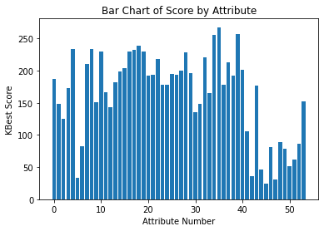

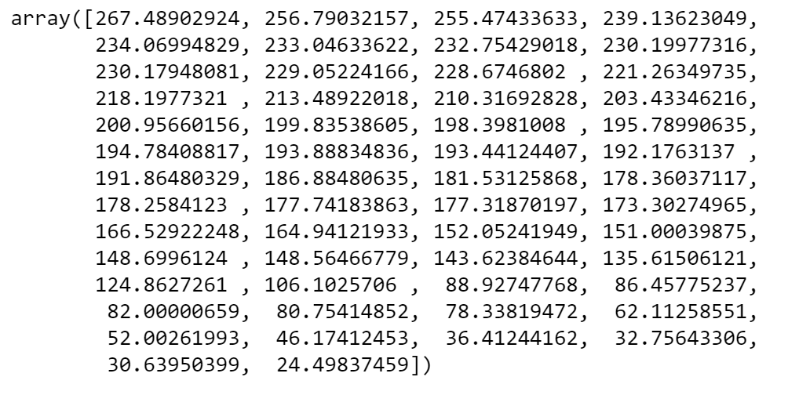

Using these two visual methods, I determined that a score of 100 is where a division can be made. Features scoring <100 would be removed due to a lack of significance. In total, there were 12 features (Atr6, Atr7, Atr43, Atr45, Atr46, Atr47, Atr48, Atr49, Atr50, Atr51, Atr52, Atr53) scored below 100 in the chi-square test. These 12 were also 12 of the 13 lowest scoring features in the correlation with target matrix and removing them leaves k=42, which nearly aligned with sklearn’s SelectPercentile() at 75% number of 40.

On the positive side. Of the top five highest scoring features on the chi-square test (Atr36, Atr40, Atr35, Atr19, and Atr9), two of them were on the top five highest scoring features in the correlation with target matrix (Atr40 & Atr19).

**References:**

Lisitsa, E. (2013, February 18). The Research: Predicting Divorce from an Oral History Interview. The Gottman Institute. Retrieved from <https://www.gottman.com/blog/the-research-predicting-divorce-from-an-oral-history-interview/>.

UCI Machine Learning Repository. (2019, July 24). Divorce Predictors data set Data Set. Center for Machine Learning and Intelligent Systems. Retrieved from <https://archive.ics.uci.edu/ml/datasets/Divorce+Predictors+data+set>.

Yöntem, M., Adem, K., İlhan, T., Kılıçarslan, S. (2019). DIVORCE PREDICTION USING CORRELATION BASED FEATURE SELECTION AND ARTIFICIAL NEURAL NETWORKS. Nevşehir Hacı Bektaş Veli University SBE Dergisi, 9 (1), 259-273. Retrieved from <https://dergipark.org.tr/tr/download/article-file/748448>.